
Company
Logotype

Cone Beam Computed Tomography- Report



Porur Dental X-rays & CBCT

Patient Name : Mr. Renin Martin | Date of Report : 02.08.2024
Age/ Gender : 43 years/ Male | Region of Interest : CBCT Full Skull
Referring doctor: Dr. C. Deepak | Indication : Implant assessment
Clinical Notes: Nil
PATIENT INFORMATION

CBCT- Full Skull provided
CBCT – IMAGE DETAILS

RADIOGRAPHIC INTERPRETATION

- Complete loss of crown and root structure in relation to 11, 12, 13, 14, 15, 16, 21, 22, 24, 28, 31, 32, 33, 34, 37, 38, 41, 42, 47, 48.
- Root stumps in relation to 17, 25, 36.
- Bone loss extending upto and beyond the middle third of the teeth that are present.
- The alveolar ridge in relation to the maxillary and mandibular alveolar ridge is present with normal trabecular pattern.

IMPLANT ASSESSMENT

 | 11 region | 12 region | 13 region | 14 region | 21 region | 22 region | 23 region | 24 region
Sub-Crestal | 2.9 | 2.9 | 3.9 | 4.4 | 3.5 | 4.4 | 4.4 | 6
Mid- Crestal | 4.7 | 4.4 | 6.5 | 6.4 | 5.1 | 4.4 | 6.1 | 8.9
Distance between the alveolar ridge and Floor of the Nasal cavity (in mm) | 13.4 | 14.6 | 13.5 | 12.8 | 13.2 | 12.3 | 10.4 | 9.6

 | 15 region | 16 region | 17 region | 25 region | 26 region | 27 region
Sub-Crestal (in mm) | 6.7 | 7.7 | 6.6 | 5.4 | 6 | 9.6
Mid- Crestal (in mm) | 8.5 | 10.9 | 7.5 | 6.7 | 9.2 | 10.9
Distance between the alveolar ridge and floor of the maxillary sinus (in mm) | 7.4 | 5.5 | 9.5 | 15.5 | 13.4 | 11.2

 | 31 region | 32 region | 33 region | 34 region
Sub-Crestal (in mm) | 5.1 | 4.8 | 4.2 | 3.7
Mid- Crestal (in mm) | 7.3 | 6.8 | 8 | 6.2
Distance between alveolar ridge and the inferior border of mandible (in mm) | 19 | 19.9 | 19.8 | 21.7

 | 41 region | 42 region | 43 region | 44 region
Sub-Crestal (in mm) | 5.1 | 3.8 | 6.4 | 7.4
Mid- Crestal (in mm) | 8.6 | 5.7 | 8.7 | 8.5
Distance between alveolar ridge and the inferior border of mandible (in mm) | 19 | 22.9 | 16.9 | 19.5
 | 45 region | 46 region | 47 region
Sub-Crestal (in mm) | 9.6 | 8.8 | 5.3
Mid- Crestal (in mm) | 9 | 10.6 | 10.4
Distance between alveolar ridge and the inferior alveolar nerve canal (in mm) | 6.4 | 8.9 | 11.2
Distance between alveolar ridge and the inferior border of mandible (in mm) | 18.5 | 20.3 | 22.3

 | 35 region | 36 region | 37 region
Sub-Crestal (in mm) | 7.7 | 8.4 | 5.8
Mid- Crestal (in mm) | 8.1 | 10.6 | 9.9
Distance between alveolar ridge and the inferior alveolar nerve canal (in mm) | 3.6 | 7.5 | 6.9
Distance between alveolar ridge and the inferior border of mandible (in mm) | 18.6 | 18.5 | 17.4

RADIOGRAPHIC IMPRESSION

- Partially edentulous maxillary and mandibular arch.
- Root stumps: 17, 25, 36.
- Generalized chronic periodontitis.

Kindly correlate with clinical findings


IMAGES FOR REFERENCE

RECONSTRUCTED PANORAMIC VIEW
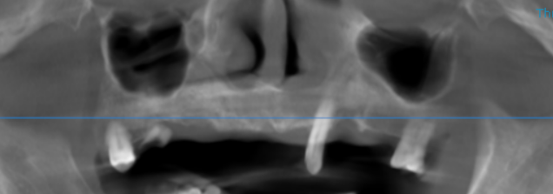

3-DIMENSIONAL VIEW
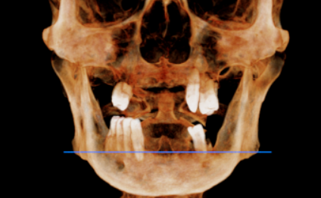

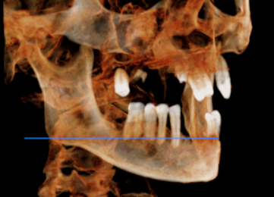

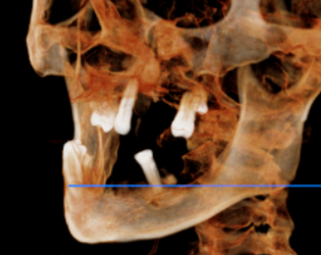

CROSS SECTIONAL VIEW

11 region | 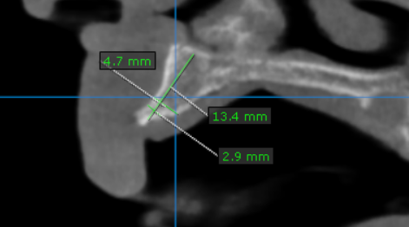
12 region | 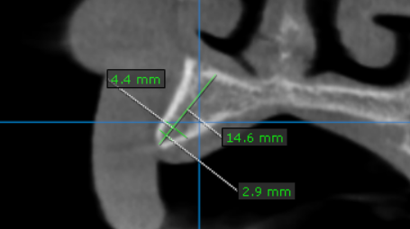
13 region | 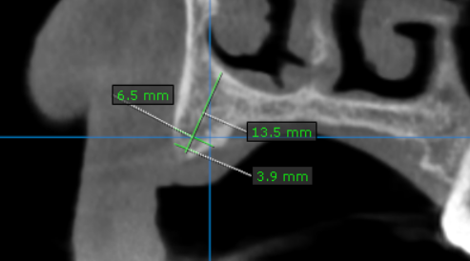
14 region | 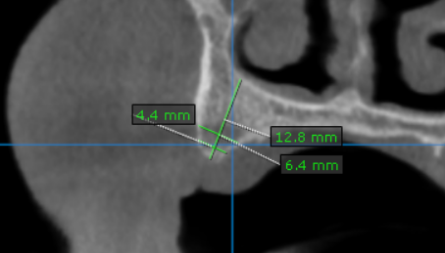
15 region | 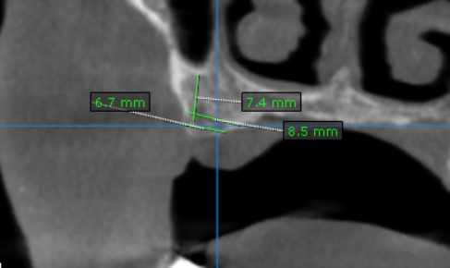
16 region | 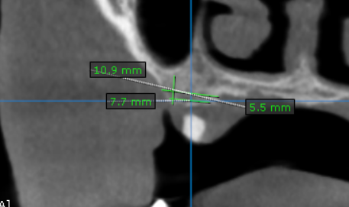
17 region | 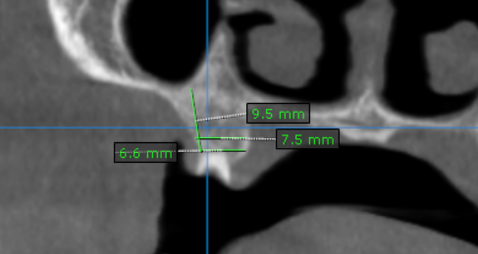
21 region | 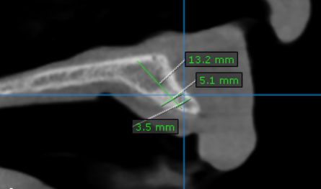
22 region | 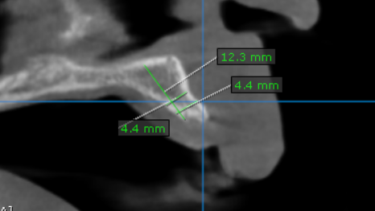
23 region | 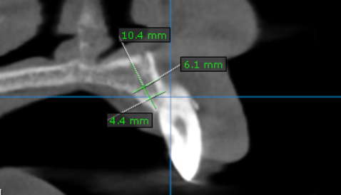
24 region | 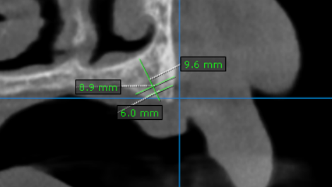
25 region | 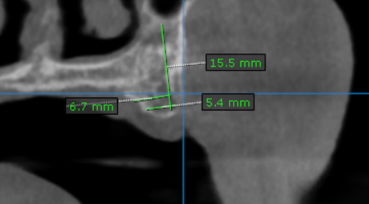
26 region | 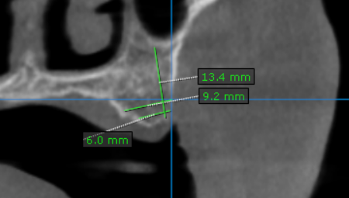
27 region | 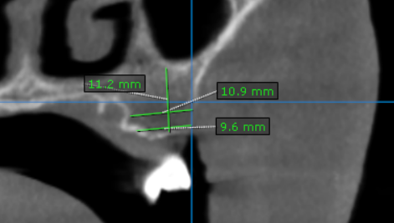
31 region | 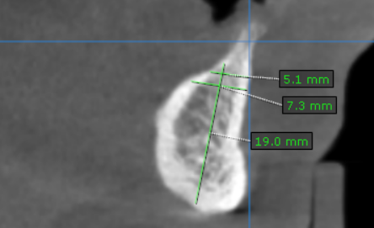
32 region | 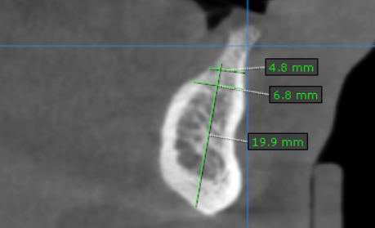
33 region | 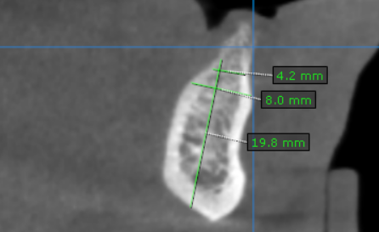
34 region | 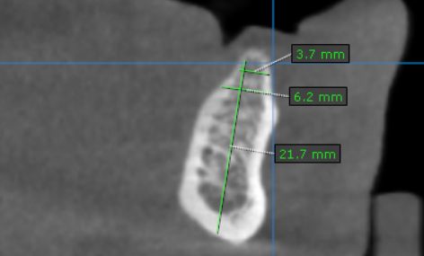
35 region | 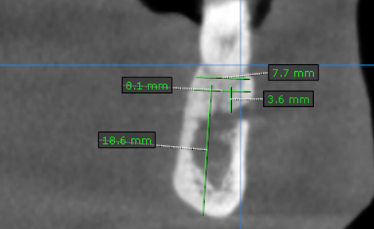
36 region | 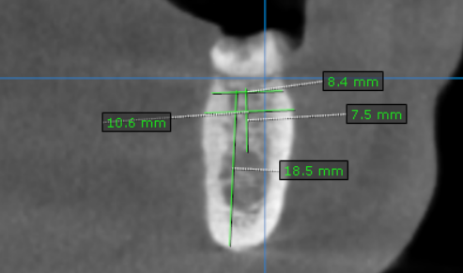
37 region | 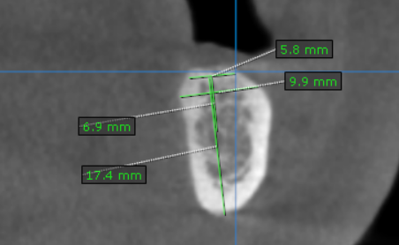
41 region | 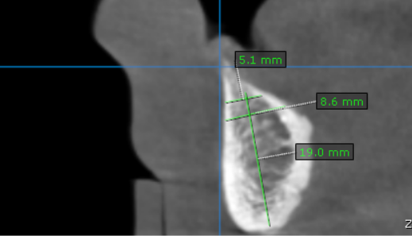
42 region | 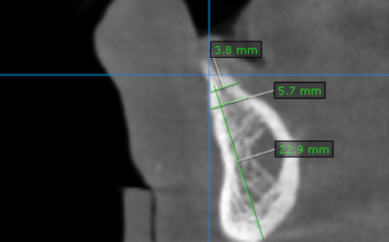
43 region | 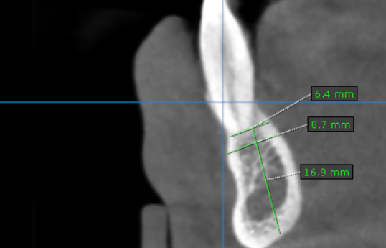
44 region | 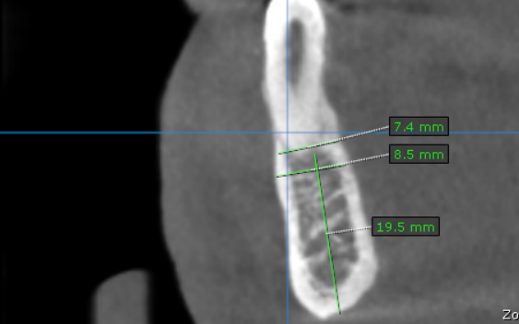
45 region | 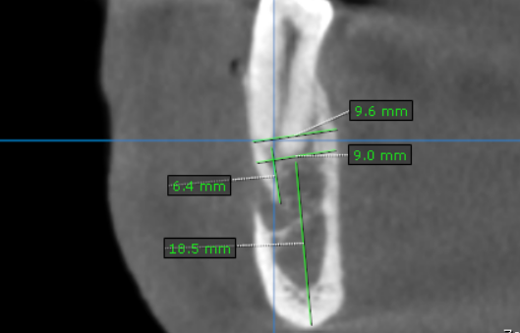
46 region | 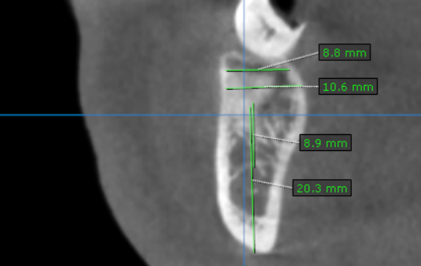
47 region | 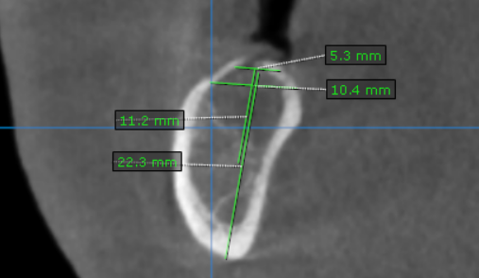

**** End of report ****

